EASO publishes a Country of Origin Information (COI) report on Eritrea

* 30TH SEPTEMBER 2019

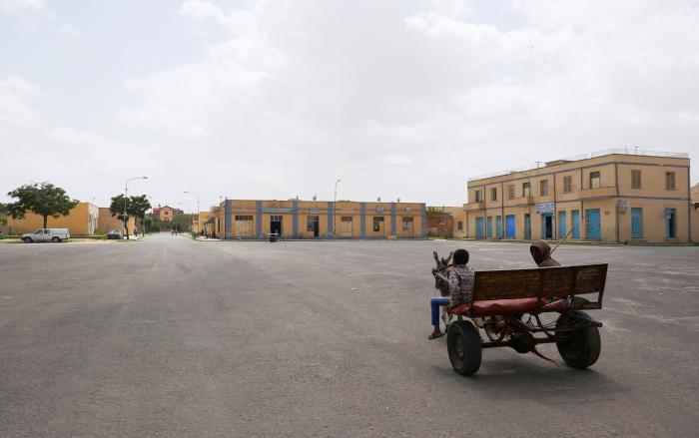

***Today, the European Asylum Support Office (EASO) published a Country of Origin Information (COI) report on Eritrea. The report provides updated information on selected topics (national service, exit from Eritrea, and treatment of returnees), relevant for international protection status determination. Between August 2018 and July 2019, more than 14 475 Eritrean applications were registered in the EU+ countries.1***

This EASO COI report on Eritrea was drafted by the Swiss State Secretariat for Migration (SEM), Division Analysis. The report updates and expands on the EASO COI report on national service and illegal exit (in Eritrea) from 2016. It provides a brief overview of Eritrea’s latest political developments, in the period 2016-2019, including the *rapprochement* with Ethiopia, the legal framework in force, and the relevant human rights issues. For the same reference period, the report then focuses on three main topics: (1) structure and functioning of the national service; (2) legal and illegal exit from the country; (3) voluntary and forced return. Transversally to the above mentioned subjects, the report details forms of punishment and treatment of deserters, draft evaders, persons illegally exiting the country, and returnees. Besides relevant public and governmental sources, the report relies extensively on interviews with key informants and experts, which were mostly carried out in the period May-July 2019.

The report was peer reviewed by EASO and other COI researchers from the following national asylum authorities: Germany, Federal Office for Migration and Refugees (BAMF), Country Analysis; and Sweden, Swedish Migration Agency, Section for Information Analysis. The report was drafted and reviewed in accordance with EASO’s COI Report Methodology.

The report can be [downloaded](https://coi.easo.europa.eu/administration/easo/PLib/2019_EASO_COI_Eritrea_National_service_exit_and_return.pdf) from the EASO COI portal.

Cover photo: © SEM, State Secretariat for Migration, Switzerland